

Challenges

and Hopes

1720 perspectives on the Catholic Church in the Diocese of Hexham and Newcastle



C:\Users\nancy.gash\AppData\Local\Microsoft\Windows\INetCache\Content.Word\Cross [Converted].eps

**Speak Lord, Your Servant is Listening**

A central part of the *Forward Together in Hope* journey so far

has been the careful gathering of and listening to the rich

variety of views and ideas, fears, hopes and aspirations

of many people from all parts of our Diocese.

We have spoken face-to-face with people at the back of churches,

at meetings of the Youth Council, the Council of Laity,

the Council of Priests and the Association of Religious.

We’ve welcomed the opportunity to discuss with representatives

from parishes and schools at Deanery meetings and elsewhere.

As well as the thousands of parishioners who have contributed

through the Parish Consultation and Questionnaire process,

we have listened to the voices of almost

5,500 young people, 1720 individuals and 43 clergy

who have taken the time to offer their thoughts through various surveys.

It is good for all of us to listen

and to reflect on what is being said.

We hope this document and the others in this series

will help us to do just that as we prepare our Diocese for the future.

*‘I hope that it will be a thriving, visible and loving presence in the North East.*

*I hope that it will be known as a ‘community of love’ in which all can be welcomed*

*and given a platform to know and love God and, filled with the Spirit of love,*

*be compelled to reach out to others, especially the most vulnerable.’*

(Hopes for the future of the Catholic Church in Hexham and Newcastle from one survey respondent)

**Challenges and Hopes**

**The Findings at a Glance**

The survey sought views about the Catholic Church in the Diocese of Hexham and Newcastle and generated 1,720 responses - mostly from a wide cross-section of interested adults - with a small number from younger contributors.

The replies were mainly from practising Catholics who are active in their parishes, but there was also a group of over 250 who are less connected with the Church - including Catholics, other Christians and those of no faith.

77.8% of participants regularly attend Mass in Catholic parishes at least weekly. 85.3% consider they are part of a Catholic worshipping community, and 77.3% describe themselves as practising Catholics.

Where people go to Mass is influenced by many things, but very important are the practical issues of *Mass times* and *location*, and the more human factors of *being welcomed,* and the *manner of the priest*. For younger groups in particular, their *experience of the liturgy* is also an important factor.

The responses indicate a good level of involvement in many facets of parish life. Some activities, such as *liturgy and worship*, were mentioned by all age groups. Other roles are more specific to particular age groups.

Over a third of those replying regard themselves as very involved already in church life. *Work* and *family commitments* are the main reasons given for not being more involved – although more telling aspects are also highlighted.

The challenges identified for parishes are mainly a concern for *engaging the young*, *falling attendances* in general, and the *pressure on the priesthood*, both as it ages and in the current *lack of vocations.*

There is little difference apparent in the way that men and women see things; both groups have similar priorities.

The younger groups often highlight *unappealing liturgy, lack of involvement and lack of vibrancy.* For the older teens and young adults there is a need expressed for better *faith and spiritual development.*

In addressing the challenges described, many wish to *engage more with young people*, to *reach out and be welcoming*, and to *be more involved as laity.*

For young adults a focus on *prayer and faith development* is asked for.

The most significant challenge from a wider regional perspective is seen as *the pressure on priests*. Clearly many of the laity regard their priests as a precious resource that they care about both in terms of the workload they have, and in the reducing numbers.

For those less connected with the Church the same issues of *dwindling numbers* and *engaging young people* appear, but a *perceived irrelevance* of the Church in the wider community is also highlighted.

Asked about what might need to change in their local church to encourage greater involvement the highest responses asked for it to be *more socially vibrant* and to have more *involvement of the laity*.

For the future, there is *a strong sense of hope* and a wish for a *vibrant and active Church*. Many desire a Church that expresses itself *in caring and welcoming*, and with an *openness to youth*.

As well as providing summary data to show overall trends, the report gives a flavour of some of the many thousands of heartfelt comments from all parts of the diocese. Herein lies a very clear message that people care passionately about the future of the Catholic Church in our region and are keen to add their energy and prayers to ensuring that it flourishes into the future.

**Challenges and Hopes**

**About this Survey**

Between August 2015 and January 2016, people from around the North East shared their views on the Catholic Church in the Diocese of Hexham and Newcastle. The majority of participants used an online survey tool but over 200 preferred the hardcopy alternatives provided to parishes or printed in the *Northern Cross* newspaper.

This report summarises their responses and presents them in a way that we hope is helpful in informing the conversations that are now taking place around our diocese as we look to the future.

As well as providing summary data to show overall trends we have ‘dipped into’ the vast pool of written comments to illustrate and enliven the report. Here we have unapologetically focussed on comments that might stimulate and challenge. We feel that to do otherwise is to miss an opportunity for development, growth and new thinking.

We are very grateful to everyone who has taken the time to present their perspectives. We have tried our best, within the constraints of a short report, to do them justice.

**Who was involved?**

1,720 people completed the survey with the vast majority (93%) aged over 25. 118 questionnaires were completed by those in younger groups.

1123 females (65.3%) and 597 males (34.7%) took part. By comparison the Catholic population in England and Wales is estimated to have a distribution of 59.1% female and 40.9% male.

Almost all of the parishes in the diocese were represented in the responses although the number of participants from individual parishes ranged widely from 1 to over 80.

Participants were asked to provide details of their background by selecting as many categories as they wished from a given list.

It is interesting to compare the two broad groups that emerge:

1. Those who describe themselves as having a ‘Catholic background’ (74.1%) are very likely to be baptised (92%) and to have attended a Catholic primary School (83.5%). 74% attended a Catholic secondary School and 1054 (82.7%) of the group currently consider themselves to be a practising Catholic.
2. The 445 people who did not indicate a Catholic background are less likely to be baptised (30.7%), to have attended a Catholic primary school (20.2%) or a Catholic secondary school (16.6%). 62% of this group currently describe themselves as practising Catholics.

A total of 154 responses were from those baptised in another Christian denomination but who now consider themselves to be practising Catholics.

**Do you consider yourself as part of a Catholic worshipping community?**

85.3% of survey participants identify themselves as part of a Catholic worshipping community and associate themselves with a Catholic parish.

The 253 people who do not see themselves in this way cover a wide variety of backgrounds, including:

* 42 practising Catholics
* 43 practising Christians of other denominations
* 32 who are religious/spiritual but not of any organised religion
* 38 who do not consider themselves religious/spiritual
* 2 from faiths other than Christianity

**The Church-going experience**

**Frequency of attendance**

Those who indicated that they are part of a worshipping community shared how often they go to Mass. 43.5% attend at least weekly and 35.7% do so more than once a week. 12% attend between weekly and monthly, and 8% only irregularly or never.

A higher proportion of the men who replied reported attending weekly or more often (84.9% compared with 76.1% of women).

**What influences where people go to Mass?**

Participants were given a list of possible reasons that might influence where they choose to attend Mass and were asked to select all those that they felt applied to them. (Hence the percentages total to more than 100%)

**The factors mentioned most were:**

* The times of Masses (54.4%)
* How welcome I feel (48.2%)
* The convenience of the location of the church (46.8%)
* What the priest is like (40.2%)

**The least important were:**

* The availability of car parking (15.3%)
* What the church building is like (12.4%)
* How accessible the church is using public transport (8.1%)
* The age profile of parish members (4.9%)

There are some striking differences between age groups here. Whilst *times of Masses* is the most important to participants aged 26 and over, for the youngest groups the *style of music* and *what the priest is like* are equal first choice.

The 11-18s highlight *How welcome I feel* while for 19-25s *What the priest is like* is first choice*. How welcome I feel* features in the top three influences selected by all of the three younger groups.

*Times of Masses* becomes more important with increasing age. For the under 11s, it ranks 9th of the 13 choices and for 11-18s it is 4th. Young adults (19-25) place it 5th while 61.7% of over 70s select it.

As well as identifying factors from a given list, participants offered thoughts about what else influenced their attendance.

***Examples of their comments include:***

* *I celebrate Holy Mass to worship God and none of the above would influence my obligation to – or where I would attend.*
* *Mass attendance must go with real hands on Christian commitment - not like getting shoppers to visit your store.*
* *Quality of the sermons and the capacity of the clergy to stretch and challenge me and deepen my faith.*
* *I used to come to mass on a weekly basis but now that we have a new priest that is not so engaging I don't really like to come to mass anymore.*
* *It is important to me that I feel the priest ‘breaks the word’.*
* *I attend Mass in several churches. Some of them make me feel very welcome, have inspiring priests, have wonderful music and welcome children and families warmly. In others these are sadly lacking.*
* *I would seek out an Extraordinary Form Mass first to meet my Sunday obligation.*
* *I don't go to church because of what it looks like or to catch up with mates. If I wanted to do that, I'd go to a pub instead. I go first and foremost because God commands us to set aside a day of the week for worship, and I go regardless… because it's God who is the most important - not me.*
* *Able to hear the priest when he’s talking – very important!*
* *Churches that do not make simple adjustments for the disabled can be VERY hurtful to those who do not have the transport to go elsewhere. They can also feel extremely rejected.*
* *This is my parish and where I will always worship, irrespective of where the building is located.*
* *…is a welcoming, supportive and a wonderful parish I am proud to belong to.*

**Involvement**

**To what extent are you regularly involved in the life of this church?**

Presented with a scale of one to five (where 1 is ‘least’ and 5 is ‘most’) participants were asked how *involved* they felt in parish life.

The replies were spread across the range, with 15.5% feeling that they are *least involved* and 11% feeling *most involved.*

They were also asked how they would have answered the same question 5 years ago. Their replies suggest that, overall, they regard themselves as more involved in the life of the parish now than they did in the past.

Many younger people place themselves in the *least involved* category. This changes as age increases (48% of the 0-10s, 29.6% of the 11-18s and 25% of the 19-25s).  The ‘most involved’ group is dominated by those over 50.

**In what ways are you involved in the life of this church?**

When asked *how* they were involved the highest responses were for *worship / liturgy* and *social events.* The pattern of involvement is slightly different for men and women, with a higher proportion of men indicating involvement in *worship / liturgy* and *finance / governance / coordination and pastoral responsibilities,* whereas women are more often seen in the *ecumenical activity, educational work, social events*, *practical support*, *spiritual development* and *outreach* categories.

*Ecumenical activity* is noticeably low, being the lowest category specified, with just 20 people specifically identifying this in their comments.

The *worship and liturgical life* of a parish generally seems to involve a mix of age groups, but other activities are less diverse. While it is not surprising that no children under 11 years are involved in *outreach*, both this very young group and the 19-25s are completely missing from the *spiritual development* and *ecumenical activity*. The 50-70 age group form a large part of those working on the *finance, governance and co-ordination* aspects.

Those replying were able to comment in their own words. **They mention a wide range of specific contributions**:

* *Parish Council member.*
* *Supporting events organised by the parish and contributions to charities supported by the church*.
* *Paths, car park, drains, attending to waste disposal bins.*
* *Principally by attending mass and other services.*
* *I stand at the back of the church and welcome late comers - Listening and sharing with folk after mass and within my local community.*

**Several indicated that they wear ‘*many hats’*:**

* *I’m a Catechist, Extraordinary minister of Holy Communion, Lay Leader, summer and Christmas Fayre Co-ordinator, Primary and Secondary School Governor, Voluntary Reader in Primary School, Choir member…*

**Others *used* to be involved but not any longer:**

* *I used to be wholly involved, found local politics too unnecessary… you had to be on the pension to be involved… a clique of mostly females.*
* *I used to be an altar server but the new priest put me off and I now don't any more*.
* *It doesn't appeal to me and, in the past, it hasn't provided me with an opportunity to live my faith. I prefer to engage with the secular world. That's where my faith can make a difference.*

**Some may get involved if they were asked:**

* *Active participation by other members of the community didn't seem to be encouraged.* *Have offered to help but not taken up.*
* *No opportunity to get involved in any meaningful way.*
* *I feel totally isolated from the church community even though the priest tries very hard to involve attendees at Mass in suitable events.*
* *I find it difficult to know where I could be best used.*
* *The feeling I get is that people either think I'm not 'up to the job' or the current groups are very tight knit and it's hard to get into these easily. It’s the same people running ALL the different committees.*

**A number of people highlight practical reasons for not being more involved:**

* *I live 35 minutes from church and the bus only runs two hourly and don't drive or I would be there much more often.*
* *I work in a job with demanding round the clock hours and it is very difficult to commit to anything especially after work leaves me mentally and physically exhausted.*
* *For family reasons, I am not always able to participate in events other than Sunday Mass but I support my parish and the wider Church financially.*
* *Not involved at all as unable to leave the house easily.*

**Others were prompted to think about how they might contribute:**

* *I’d like to be involved with liturgy, catechesis, outreach to the poor and marginalised and just offering my services where they may be required.*
* *I do feel that I could make more of a push to contribute in a less regular way and am sorry that so far I have not.*

**Some clearly find their involvement to be a source of friendship and fulfilment*:***

* *I have made some fantastic friends that I would never have known if it hadn’t been for my priest pushing me on.*
* *My social life revolves around the church.*
* *I know a lot of other people who attend and do feel that I belong to the community even though I am not that heavily involved.*

**Others see it very differently*:***

* *I have found it to be very unwelcoming at all 3 of the Catholic churches which I attended before I became a member at Easter this year. Many people who are enquirers would probably walk away and not continue to explore Catholicism as possibly being their spiritual home.*

**Greater Involvement**

All participants, regardless of background were asked

‘What would you say are the main reasons you are not more involved in the life of your local Catholic Church at the present time?’

Over a third (35.1%) of those replying already feel very involved in their community. Work and family commitments are given as reasons for not being further involved by over 30% in each case. 252 people (16.7%) selected both work and family commitments preventing them being further involved.

The largest difference in response between men and women here was the degree to which women’s family commitments prevented them being more involved. 32.7% of women selected this as a reason (their highest scoring factor) and 26.6% of men (for whom it ranked second to their work commitments at 29.2%).

As would be expected, a high proportion of the 19-25 and 26-50 age groups had work commitments rated high, but the 11-18s also had this at 22%.

Mobility and health problems were an issue for the over 71s (26.5%). Many of this group also reported being very involved already at 55.8%. with the 50-70s reporting 46.2% on this factor. Family commitments were most restricting for the 26-49s (49.3%).

**Ways your local Catholic Church could change that might make you want to become more involved**

Responses to this question were quite low, with the highest response (for a *more socially vibrant church*) rating just 9.5%. *More lay involvement* was second (7.2%) and *youth activities* the third highest at 4.8%. *A wider variety of worship* is next with 4.6%, and *leadership* and *adult formation* are at the end of the list with little response.

* *For various reasons my life is rather busy at the moment so it is not easy to get involved. However my wife and I are rather new to the area and would love the opportunity to make friends with Catholics in the region. However we have no idea how to set about doing that.*
* *Just ask me who I am and what I could do to help. I used to do a lot of work.*

The same request for a *socially vibrant church* is top of the list for both men and women, and both put *lay involvement* second, but with men giving it a noticeably higher rating

Key areas for the younger groups are *youth oriented activities* for the 11-18 year olds, and *socially vibrant churches* for the 19-25s. These young adults also put a *wider variety of worship* on their list of wishes (12.8%).

* *I hope that we will be a community of more committed and active disciples that have a deeper love and understanding of the Gospel.*

**Challenges Facing the Church**

**Parish Challenges**

Those belonging to a worshipping community were asked to identify the three main challenges facing that community, and to give a personal view on how the parish should respond.

The next largest topic, mentioned in 15% of responses, was the issue of *ageing congregations* and their *sustainability.*

**Three challenges were particularly common:**

* A failure to appeal to the young (38.7%)
* Falling Mass attendance *including a sense that people are engaging less with church life* (28.9%)
* Pressure on the priesthood *including declining numbers of vocations and ageing priests* (26.2%)
* *Insufficient younger people coming into the church – the average age of the congregation must be around 60.*
* *No children at Mass now, no church in the future.*
* *People of my age are not prepared to do as much voluntary work for the church as the older generation are currently doing.*

All other challenges were mentioned by less than 8% of participants. These were *Diminishing resources* (7.1%), *Developing lay ministry* (6.6%), *A failure to engage with contemporary culture* (6.4%), *Unappealing liturgy/worship* (4.6%), *A need for deeper spirituality* (4.3%), and *The dubious standing of the Church* (including scandals and wider lack of interest from the public) (3.1%).For all age groups *Lack of appeal to the young* is a very important factor.

For the youngest (0-10) the most significant factor is *Unappealing liturgy* (45.5%), then comes the *Lack of appeal to young*. They are also the only group to highlight issues that relate to *‘engagement with contemporary culture’* in their top three.

The 11-18 year olds put *lack of appeal to the young,* first but rate *diminishing resources* and *unappealing liturgy* higher than other factors, with *pressure on priests* in fourth place.

Young adults (19-25) agree in putting *lack of appeal to the young* first, then comes *Mass attendance,* but they are the only group to rate *‘need for deeper spirituality’* in their top concerns.

Concern about *ageing congregations* rises in importance as age increases. The over 70s also mention *deeper spirituality* (7.3%). The 50-70 year group most mention a need to develop *lay involvement*, though still at a comparatively low rate (9.5%). For all age groups *Lack of appeal to the young* is a very important factor.

**Challenges facing the Catholic Church in the North East**

All participants, whether or not part of a worshipping community, were asked what they saw as the main challenges facing the Catholic Church in the North East. By far the most mentions were of issues relating to *pressure on priests* (38.6%).

*Concern about engaging young people* has been a constant theme in responses throughout the survey, and it is again high in the ratings here with 27.9% indicating *lack of appeal to the young*. *Mass attendance* (“Falling Mass attendance, including a sense that people are engaging less with church life”) follows closely behind at 24.4%.

* *Working out the best way to utilise our clergy and promoting vocations to the priesthood, the religious life and the permanent diaconate.*
* *Attracting a younger, wider age-profile.*
* *Relevance – why should I believe? Why should I be a Catholic? Why should I go to church? What does the church stand for?*
* *Get people through the door. Or go out and invite them in. Then get them interested by showing how the God can enhance and / or change their life.*

*A wider perception that the Church/Faith is irrelevant* was a smaller but still significant factor (17.8%) among the full group of participants.

The younger age groups again show different priorities. For the 0-10s almost the only priority was *lack of appeal to the young* (64.5%). This was still top of the list for the 11-18s at 42.4%, and followed by *perceived irrelevance* of the church with 27.3%.

**Responding to the Challenges**

Having identified the key challenges participants who are part of parish communities were asked “*What is your personal view about how your parish community should respond to these challenges?”*

The most frequently mentioned, by a large margin, was ‘more engagement with youth’ with 36.8% of responses highlighting this.

Next were *reaching out to the wider community / other churches/be more welcoming* at 23.6% and *more lay involvement* at 19.1%.

The next most frequent responses were for *Improve the social dimension of parish life* (15.1%), *Rethink/revamp worship/liturgy* (12.3%), and *prayer and faith development* at 10.7%.

The lowest response was for *married priests* at 4.8% of responses.

The priorities are largely the same for the different age bands, though 11-18 year olds stress *reach out to wider community* and *rethink/revamp liturgy* alongside *more engagement with youth.*

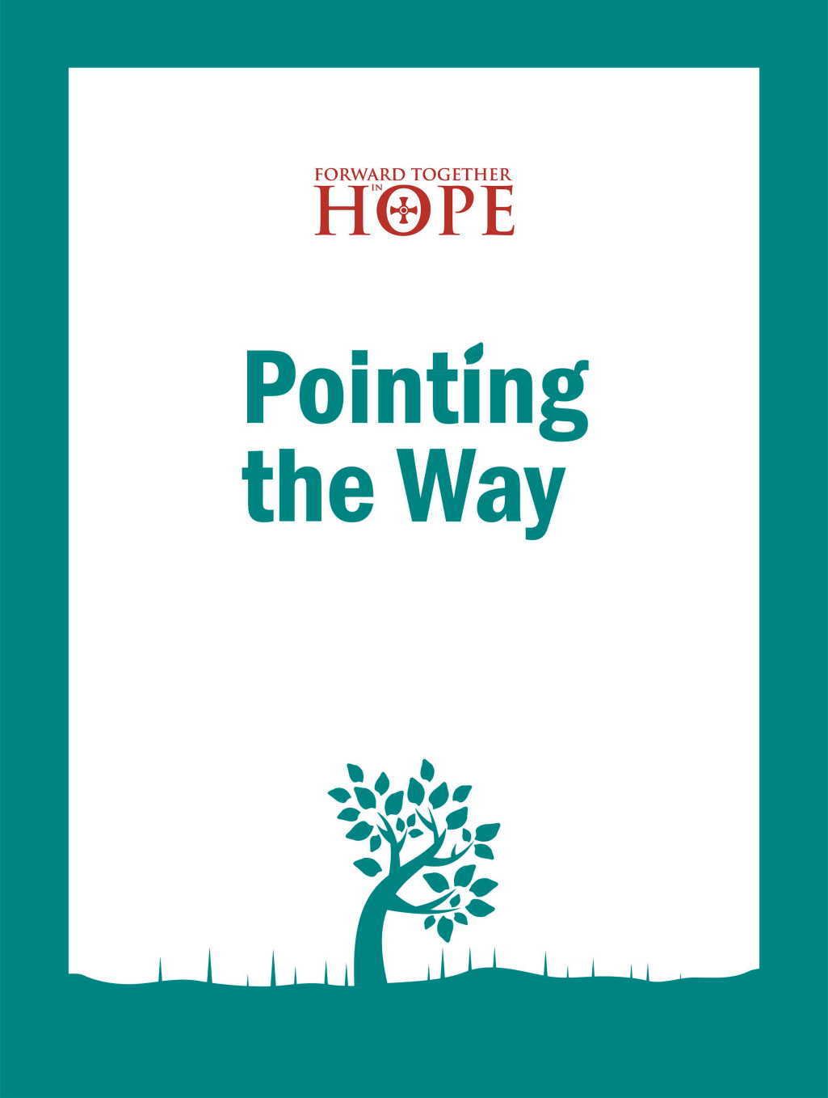

*Lay involvement* was less important to the younger age groups. The 19-25s stressed *prayer and faith development* echoing the call for deeper spirituality in an earlier question.

When asked for suggestions about how some of these challenges might be addressed, **several appear to be ‘scratching their heads’:**

* *I really have no idea. I wish I had a good idea about my response, but I haven't. I think that it is too late to do anything. Once the 60+ generation get past it...then the present structure is finished and we start again almost in a missionary situation like St Aidan. The present structures are finished.*
* *Regretfully I don't think that there is anything that the parish community can do in addition to what it is doing now. If the Parish Priest was to be removed then the parishioners who would take over would be elderly and completely out of touch with the generations that are needed for a vibrant church.*

**Yet others were ‘overflowing’ with practical advice**. Indeed, one respondent single-handedly provided an ‘ideas manual’:

* *Solid Catholic education programme for young people in school - involve them on PPC. Welcome leaflets, a welcome table, a visitor’s book, and welcome person at Sunday Mass would encourage enquirers to come back. The website needs totally updated, colourful, informative, welcoming. Young people who are IT skilled could help with this. Fellowship is non-existent - it needs to be developed, people walk into Mass and worship and walk back out. Pastoral care is vital for people at any time, the way the priests work needs to be totally looked at and perhaps a rota system put in place with set days off. Perhaps base them in one central place and people could go there to see them with at least one being available on a shift rota. There are also too many churches - some need to close.*

**Others again offered shorter but equally practical suggestions:**

* *There should be a greater variety of liturgies (not just Masses) throughout the year which may appeal to a wider age range.*
* *We need to try to arrange some social activities to attract the families. Have benches outside church so that during nice weather people can sit and chat after mass. More social get-togethers with a Christian theme and a cup of tea.*
* *Talk to young people about how they feel about the institutional church, why they feel it is not important in their lives how they engage with philosophical, ethical and moral problems and how they fulfil their moral obligations.*
* *Listen to the young people...*
* *Jesus needs to be taken into our communities and schools. We must not be afraid to celebrate Christ and profess our faith.*
* *Welcome everyone …challenge everyone to seek out Christ in a way that best suits them.*
* *Stop being territorial about a building made of bricks.*
* *Better relationships with primary and secondary schools is key. There is some work to be done here, for example invite children to sing in the choir at Sunday Mass - some of the teenagers could be invited to read the liturgy on Sunday. In doing this we could then better engage with the children's parents and hopefully encourage those who don't currently go to church to come along to support their children.*
* *Accept that both forms of the Mass are legitimate. Show respect for the Real Presence and accept the authority of the clergy.*
* *The very heart of the worldwide Catholic Church and its beliefs need to evolve in order to survive in the future. Only then will any parish community be able to respond to these and all challenges.*
* *Priests need to be seen actively outside (our priest is) rather than waiting for people to come to them for talks about faith. Old fashioned missionary ideals are needed again.*
* *Try to be open and inclusive and keep a wider view in mind. Be thankful for the arrangements we have but embrace changes that become necessary.*
* *As a mother of three children aged 7, 6 and 4 my husband and I have been given a huge responsibility by God to bring these children up in the Faith. It is my fervent belief that it is FAMILIES who are going to sustain the future of Christ's Church.*
* *A small group of well-informed younger parishioners could visit secondary schools and with the help of RE teachers try to engage with the sixth formers to find out their views.*
* *Stop thinking that the schools will take care of young people's needs. Ask young people what they want and act on it.*

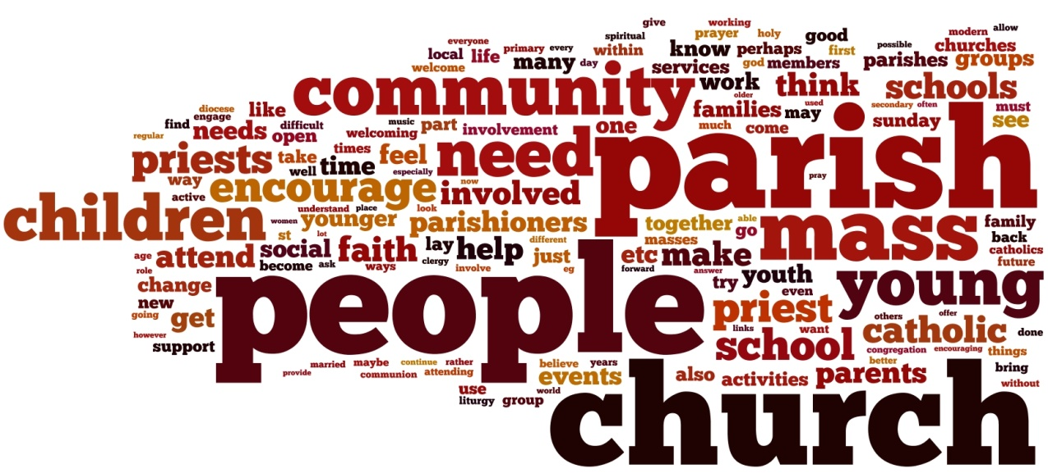

* *Admit women and married priests.*
* *More chances to chat with young and older Parishioners over a coffee.*
* *Use the talents which exist in the parish much more and open the door to encouraging more to be involved, especially the young people.*
* *We need to be a 'smiley' parish - we do a lot to make people feel at home but we mustn't become complacent.*
* *Open days at churches inviting the public in to learn about what we believe or we could experiment with street preaching or even door knocking.*
* *I think that the Church community often feels this need to hide or water down the truths of the Church in order to engage with young people. However I find that young people actually engage best when they hear and understand the truth.*
* *Being more pro-active in looking at First Communion and Confirmation programmes to see how we can welcome and encourage parents of the children and young people involved to become involved themselves in the parish community. To empower them to see that they too have something to offer.*
* *I think there needs to be much more emphasis at church and in the wider community about the importance of the role of parents as spiritual guardians for their children***.**

**Hopes for the Future**

In an open question (*How do you hope the Catholic Church in the North East will look in 15 years’ time?*) participants were asked to identify their hopes for the future and 1421 people took the opportunity to reply.

The hope for *a populous and vibrant church* in the future emerges strongly in the survey, with 42.7% giving replies expressing this hope.

The next most frequently expressed sentiment is the hope for a *more caring and welcoming church* (23.2%). Being *more oriented towards young people* follows closely at 21.5% and then the hope that the church becomes *more engaged in the world* (13.4%).

After that come *greater lay involvement* (11.6%), *more priestly vocations* (9.4%) *and a hope for ‘continuity’* (9.3%).

The lowest mentions were for *married priests* (7.6%), *female priests* (4.5%) and *more inter-parish initiatives* (2.3%).

The response by age does not differ greatly, though the optimism of the 19-25s in mentioning a hope for a *populous and vibrant church* in 54.5% of replies does stand out.

11-18s express a strong hope for *more youth focus*, and the 0-10s for *engagement in the world*.

Hopes for the future are expressed eloquently in comments from many respondents. The examples below give just a flavour of their wide range.

* *Vibrant and energetic. Looking forward instead of doing things how we have always done them. I hope it will be thriving - full of young people and children.*
* *I hope it will relate more to people's everyday struggles and not be critical of different life situations or contexts.*
* *Younger and forward thinking. Probably smaller. Faithful to the Magisterium.*
* *Fewer churches, more influence in the hands of the laity. Churches which remain being vibrant and welcoming. Parishes and schools being more integrated. Schools are where our young people are!*
* *I hope there will continue to be more priests ordained.*
* *We need to have a married priesthood and encourage those priests who left to get married to return.*
* *Priests and laity cooperating ever more closely so that the parish will be a better community, where everyone appreciates the work that others do in maintaining the life of the parish.*
* *I would like more people to view the Catholic Church as a positive force for good in the area and to feel it is somewhere people can go for help and support.*
* *I hope the John Paul II Award will prove effective in increasing involvement of young people in parish life.*
* *Vibrant, diverse and inspirational parish communities. Parishioners taking on more active roles of service to support Parish Priests.*
* *Active youth ministry. Strong links between parish/school/home. Outstanding teachers in our Catholic primary and secondary schools. Increase in number of seminarians. More people 'coming back' to church.*



***I hope that it will be known as a ‘community of love’ in which all can be welcomed and given a platform to know and love God and, filled with the Spirit of love, be compelled to reach out to others, especially the most vulnerable.***

* *A personal relationship with God - free from rules that restrict. Working together in collaborative ministry, not restrained by hierarchy. A church which offers a variety of liturgies, attractive to a range of people of differing ages, interests etc.*
* *Parishes willing to join together for worship, not always sacramental. Communities will focus on helping the most needy, all ages will work together, appreciating the talents they can bring.*
* *Modernised and diverse.*
* *I hope it will be a vibrant flourishing community at the centre of society relevant and important to the whole community.*
* *I always pray for more ordinations and put my trust in the Holy Spirit. I would like to see more families involved in church activities. I would like to see the church as a vibrant part of the wider community being more inclusive of resting Catholics, remarried and immigrant people.*
* *I hope that the great legacy of Catholicism in the north east thrives and adapts. We should be hopeful and look for ways we can all use our talents. There is greater need than ever to provide witness and ensure that our 16 year olds in catholic schools are the engaged young 30 year olds.*
* *More people taking an active part in the life of the Parish Community. More young people actively involved in the Parish Community.*
* *The parish playing a more active role in supporting people in need in the local community. Parishioners working together within Parishes and Deaneries. Schools more involved with the Parishes.*
* *Full of young people helping the less able bodied to their pews. Lots of young ministers assisting during Mass*
* *Great musicians, mass for children, which it is already in lots of churches I think you are doing great job.*
* *Approachable, friendly and full of joy.*
* *The church needs to be seen as the "hub" of the community, not just for its congregation but for the whole community. The priest (I hope we still have one) should know his congregation and be around for them in times of laughter and sadness.*
* *Married priests, permanent deacons in more parishes. More young people involved in the church. More opportunities for adults to reflect on and grow their faith.*
* *I hope the Roman Catholic Church will put back into the Church the adoration and glorification of God. Whilst the Roman Catholic Church puts people first and God second as it does it will always have problems.*
* *Outgoing, part of young people going out with its own high Street cafe for all ages. Faith to be supported like football or TV shows and talked about.*
* *I would like to see more Catholics practising their faith and to be proud of being a Catholic. I feel that here in the UK they are frowned upon, and the Catholics themselves are shy of their religion. In South Africa, people are proud of their beliefs, and that's how we should be here!*
* *Vibrant and open to new ideas, but with a clear Catholic identity, centred on the teachings of Christ and the values of the Gospel.*

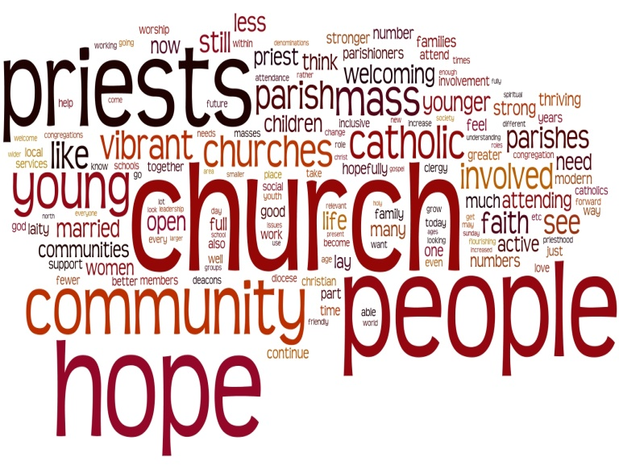

**Is there anything else you’d like to say to us?**

At the end of the survey we gave the respondents an opportunity to add any other comments that they wished to make, outside the constraints of answering a particular question. This is a selection of the ideas, comments and thoughts that were contributed.

* *The diocese often seems obsessed by a very dated Vatican II vision of the church, especially in its liturgy and teaching. This has not given the local faithful a sufficient foundation to sustain and grow their faith. Acoustic folk masses may have been daringly modern at one time but now it just makes younger peoples toes curl!*
* *The laity is not the answer. Attracting more men to the priesthood is.*
* *As there is little opportunity to put it "on record" how much I appreciate the tireless work of the clergy of our diocese especially those elderly "retired" priests who contribute so much to so many.*
* *I do feel that the diocese puts a lot of praise on the YMT for its ministry to the youth and yet, at least in our parish, this doesn't translate into Mass attendance.*
* *No theology is being done about homosexuality; what sex is for among older or sterile couples; the difference between men and women (these are worldwide problems). Inclusive language.*
* *Perhaps it would improve matters if everyone accepted the following;*

1. *I and everyone else are fragile so please handle with prayer.*
2. *Please be patient God hasn't finished with me yet.*
3. *I may not be much but I am unique.*
4. *Treat everyone you meet as if they were Jesus.*

* *I just would like to say that I have been attending a Catholic Church for 30 years and I am not Baptised Catholic.*
* *We are encouraged by the Holy Father to be joyful Christians, yet so many faces I see in the churches in the North East are not full of joy! We should seek to give our very best to the glory of God, whether that's as a cleaner, flower-arranger, altar server, chorister...we shouldn't be content with an "anything is good enough" attitude.*
* *The church I attend is a big congregation and it makes such a difference. The people are happy and the singing and band are good. I have been to some churches where that is not the case. It can seem dour and stuffy and would put off a first time attender and children.*
* *Father Y is a wonderful parish priest and I have never seen a priest who can involve and keep the children focused the way he does.*
* *The abuse scandals have undoubtedly weakened the credibility of the church, as never before. Unless the church takes radical, brave, steps to engage with the world, and to transmit the authentic gospel message of love, it will become increasingly less relevant to most people in society and become a sad group of elderly devotees who pray in a miasma of incense and hanker after the old days.*
* *Whilst I am not Catholic I have been made to feel very welcome whenever I have been to church. I personally feel that the community at St. Y’s is very welcoming. As a non-Catholic with a non-practising husband it was daunting for me to first attend church. Perhaps a small meeting for new parents at the school would be helpful to take us through what happens at mass and how we should or should not participate. And also an overview of what our role is as parents brining up a child in the catholic faith. There are various religious ceremonies throughout the year and a 'beginner's guide' from school would help me to understand what my child is learning at school. I am very impressed with how well the school involves parents when it comes to school Masses at church.*
* *My biggest concern is the lack of priests and the extra strain that is being put on the existing ones by making them look after more parishes on a shared basis. This can only add to the stress that they must deal with and affect what they are able to do in each other of the communities that they look after.*

***‘So what?’***

***…or how might we respond to what this survey is telling us?***

This report presents a summary picture of the views of many people who worship in our parish communities – as well as some who are ‘looking in’ at us. How closely does what is being said reflect your own experience? Is there anything here that might prompt you to look at things differently?

Perhaps we can all consider the results and think about how we might respond as individuals, as parish communities and as a Diocese.

***Some of the many things we may wish to reflect on and pray about include:***

* *Who do we regard as part of our parish or worshipping community? Are there others on the periphery that we could welcome?*
* *How easy do we make it for people to attend our Masses and other worship?*
* *Is our publicity attractive to others?*
* *How do we welcome visitors, strangers and those who attend each week?*
* *How many people in the community do we know by name?*
* *How might we encourage and support both existing parishioners and those new to us to become involved in the parish activities?*
* *Do we personally invite people to join in?*
* *How inclusive or exclusive do we appear?*
* *How well do we share transport?*
* *What does the balance of parish activity look like – or where is most of the energy focussed?*
* *Does it look more like ‘maintenance’ or ‘mission’?*
* *What can we do to reach out more effectively to the wider world around us?*
* *How might we engage better with our young people, both socially and in living our faith?*
* *How strong are parish links with primary and secondary schools?*
* *Are we providing opportunities for responding to the request for better faith and spiritual development?*
* *How can we work with our priests as the workload upon them increases?*
* *How can we lighten their load and nurture and sustain them?*
* *How can we foster vocations?*
* *In what ways will each of us individually contribute to the aspirations voiced of making the church more ‘vibrant and populous’?*
* *How well do we communicate both within and beyond our communities?*

*… and, no doubt, there are other areas that you will identify as being important to you or your parish situation which warrant thought, discussion, prayer and action.*



***Acknowledgements***

A great deal of work has gone into producing this survey report. It started with the idea that we wanted to hear what people in our diocese think about our Church even if they are not actually part of our worshipping communities. God sent his Son into the world because he loved the world, so we wanted to discover how others in the world actually do see us.  Some parishes found imaginative ways of introducing this on line questionnaire to those who do not worship with us – via parents and grandparents of children who attend our Catholic Schools, for example. Around 250 (14.5%) responses were from people either not connected or loosely connected with the Church.

We also wanted to hear from people in the Church who might not be able to join groups in the parishes to voice their views and from people who felt that their views might not be heard in a group. Our hope was that a voice could be made available to anyone from any part / outside of the Church and with different views within the Church.

We had very professional and solid support from Professor *Karen Kilby* and *Dr Matthew Guest* of the Centre for Catholic Studies, University of Durham. They helped us to develop and pilot the survey.

Once the survey ‘went live’ before Christmas 2015 we had to begin to invite volunteers from around the diocese to help us with the mammoth task of coding all the narrative responses in order to make analysis possible.

*Many volunteers* have helped us with every stage of this process, and the names of all those who have helped at every stage are included at the end of the document **Exploring the Way with Our Neighbours.**

All of this had to be input and once again we have been blessed with great assistance from colleagues in the diocesan office. They have been most generous with their time and expertise. Finally everything had to be analysed and reported upon and *Joe Ronan* has carried out an enormous amount of work to arrive at the summary report you have before you.

Thank you to everyone involved in the collaborative effort that has allowed this initial idea to come to fruition.  We hope that you find this summary report of real value as we continue to think, pray and consult about how our diocese can flourish into the future.

Jim O’Keefe, Tony Sacco, Nancy Gash



OrLOrL

OrL

OrL

OrL

OrL

OrL

The *Forward Together in Hope* team: Jim O’Keefe, Tony Sacco and Nancy Gash can be contacted on:

Telephone: (0191) 243 3304 E-mail: hope@diocesehn.org.uk

Diocese of Hexham and Newcastle, Department for Development and Renewal

Tel: (0191) 243 3304 E-mail: hope@diocesehn.org.uk Web: www.hope.rcdhn.org.uk

©Diocese of Hexham and Newcastle – June 2016

Also available in other formats

